73.03.23c
To James Casey
73-5319, unit 417, VPRS 44 inward registered and unregistered correspondence, VA 538 Department of Crown Lands and Survey, Public Record Office, Victoria.

Melbourne bot Garden
23/3/72
Sir,
In compliance with your request, conveyed to me this day, I have the honor to explain, that the herb, of which specimens were transmitted by Mr. M. B. Carroll of Ararat, is phytographically known as Lobelia pratioides, an account being given descriptively of this plant in the fourth volume of the Flora Australiensis. Nearly twenty years ago in a report printed for Parliament, I pointed (Report 1853 pag. 6) to the intense acridity of the indigenous Lobeliaceae, analogous to that of the medicinal Lobelia inflata of North America, the latter an important remedy in asthma, if carefully administered, also in chronic bronchitis and laryngitis. The geographic range of Lobelia pratioides, as far as hitherto ascertained by myself, is from near Lacepede Bay, in South Australia, to the Grampians, Ballarat, and Port Phillip. This particular species is also known from the North part of Tasmania. The same Lobelia has been sent to me from the Geelong common, where likewise recently many deaths of dairy cows occurred, and the Chief Inspector of Sheep has been informed that cattle have lately also died at Maidstone and Braybrook from the effect of this herb. Taking into consideration the well known poisonous properties of the Lobeliaceae, and observing that at various localities by observers independently of each other, many deaths among cattle, horses and sheep has been traced to the Lobelia pratioides, I am led to think, that their assumptions of the highly deleterious properties of this herb are correct. When pasture fodder is much reduced during the autumn on places probably overstocked, it may easily occur that the pasture animals will browse on a herb, such as the Lobelia, then still growing in moist localities, while at seasons more favorable for pastorage, they will not touch the herb mentioned, or may consume it only in so small a quantity along with other food, as not to be destructive to them. Similarly the Swainsonia Vetch proves here generally only dangerous and deadly, when in the heat of summer on dry spots other plants largely fail, on the pastures.
I do however not think, that the dangerous properties are here restricted to this only one of the Lobeliaceae; contrarily we will have to guard the stock against all the species of this order of plants, of which thirteen species occur within the limits of the colony Victoria, viz: Lobelia gibbosa, Lobelia rhombifolia, Lobelia anceps, Lobelia surrepens, Lobelia purpurascens, Lobelia pratioides, Lobelia gelida, Lobelia platycalyx, Lobelia concolor, Lobelia puberula, Lobelia pedunculata, Isotoma axillaris (a particularly large and dangerous species) Isotoma fluviatilis. The question of the noxious character of these weeds might easily be set at rest, if a quantity of any suspicious species was administered (perhaps under the supervision of a veterinary surgeon) to various pastoral animals, for test as to the quantity causing death, and as to the remedies to be timely employed. Cases of deaths of horses and cattle caused by Lobelia inflata are on record in the United states of N. America, while in West India the same results take place with Isotoma longiflora. The main active principle is Lobelin, and alkaloid liquid, which to some extent chemically may be compared to Nicotin. Perhaps I may be permitted to advise, that whereever on pasture ground the Lobelia pratioides or any other species of that genus may occur abundantly, measures should be taken to plough the ground, and then to sow it with the seeds of deep-rooting fodder plants, such as perennial grasses of vigorous growth, Luzern, clovers, &c. For altho' this would involve in first instance considerable expense, the final advantage of this measure would more than compensate for the expenditure incurred, as in all probability the Lobelia weed, which is perennial, would be suppressed, and the area be rendered far more productive by supplanting for a noxious herb a continuous growth of highly nutritive plants.
I have the honor to be,
Sir, your obedient servant
Ferd von Mueller,
Direct. of botan. Garden.

The honorable J. J. Casey,
Minister of the Lands Department.

Isotoma axillaris
Isotoma fluviatilis
Isotoma longiflora
Lobelia anceps
Lobelia concolor
Lobelia gelida
Lobelia gibbosa
Lobelia inflata
Lobelia pedunculata
Lobelia platycalyx
Lobelia pratioides
Lobelia puberula
Lobelia purpurascens
Lobelia rhombifolia
Lobelia surrepens
Lobeliaceae

For a published version of this letter, see B73.07.01, pp. 51-2.
M's error, the printed version is 1873 and the file containing this letter is also 1873.
On 19 March, Carroll had sent to the Secretary of the Board of Agriculture 'a small jar containing the contents of the Stomach of a Sheep that died this morning, and a packet containing Herbs taken from the Paddock where the sheep died', asking for information about why the sheep died and if the herb was poisonous. His inquiry was duly forwarded to M. All places named are in Vic., unless otherwise specified.
Bentham (1863-78), vol. 4, p. 131. There is a marginal annotation at this point: 'Take in plate', evidently referring to the picture that appears at this point in the published version of the letter: 73-03-23c_image01.jpg 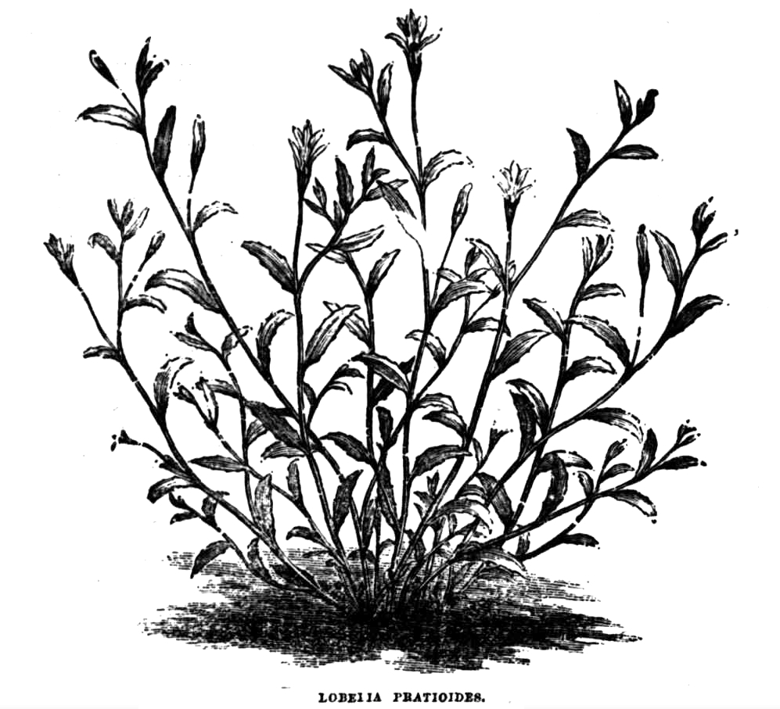
See B53.10.01.
The printed version has 'W. Gippsland'.
See also M to J. Kerr, 23 March 1873 (in this edition as 73-03-23b).

